Day in the Life: Volunteering at Citizens Advice New Forest
‘I had no idea how fulfilling the work would be’
Citizens Advice New Forest is a local charity giving people in the New Forest the support they need to find a way forward- whoever they are, and whatever their problem.
Citizens Advice offers confidential and impartial advice online, over the phone, and in person, for free. In 2018/2019 alone they helped 7,000 people in the New Forest with over 16,000 issues, ranging from benefits to relationships and housing.
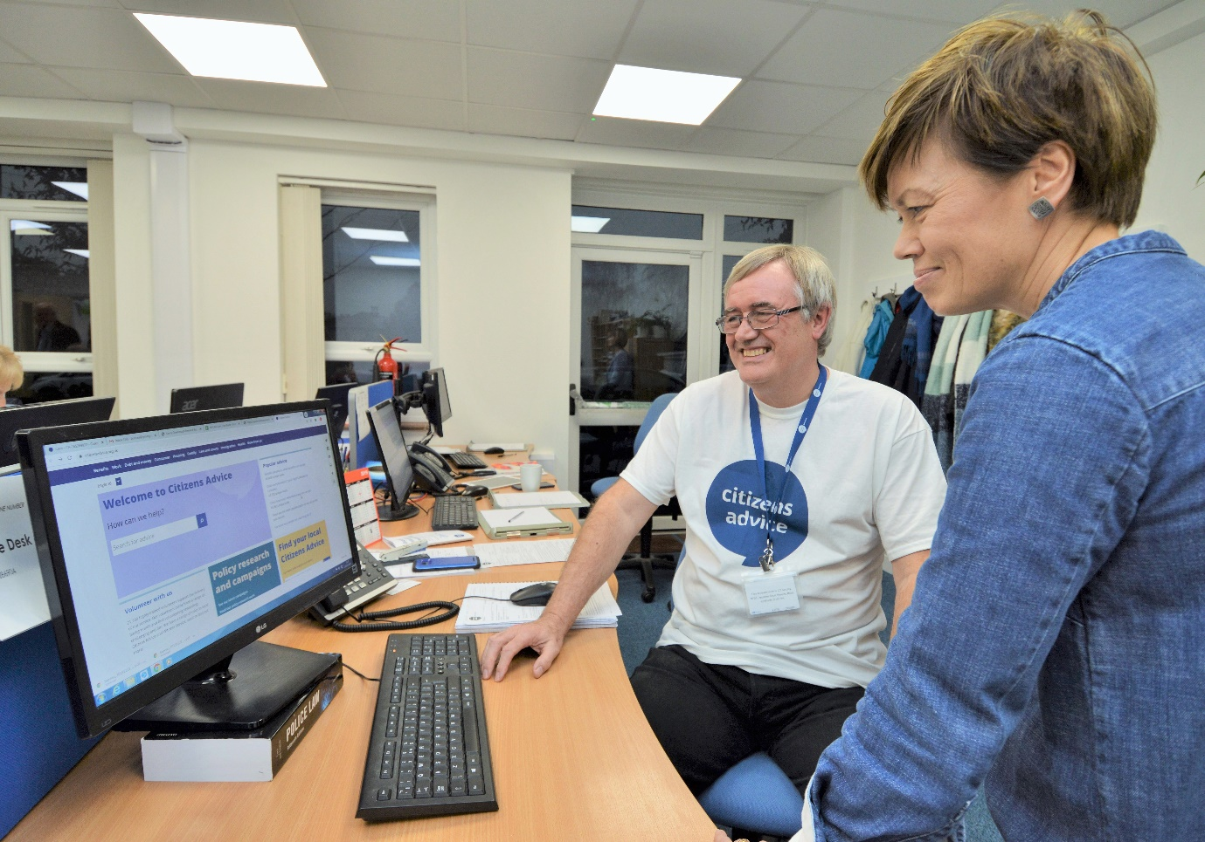

Paul Boynton is a Supervisor and Adviser who has been with CANF for ten years. Paul was previously in a Senior Management position at Heathrow and Gatwick airport, and found Citizens Advice while looking for a meaningful volunteer role after retiring and moving to the New Forest.
We talked to Paul to find out what a day in the life of a volunteer adviser really looks like, and what advice he would give for people interested in volunteering at CANF.
What does a day in the life of a volunteer adviser look like?
The day starts with a review of the diary to see what appointments we have and to allocate each client an adviser from our team of volunteers. This gives us a chance to look at the particular issues our clients have and research how we can help.
Citizens Advice has five local offices with volunteer teams across the New Forest. I volunteer close to home at the Lymington office, which is the hub for Adviceline, our telephone helpline for people calling from the New Forest. At 10:00am Adviceline opens and we often have clients queuing up to be answered.
Steve
My first call of the day is from Steve, a self-employed taxi driver, who is struggling to pay back a £5000 loan he took out to tide him over when he had a kidney transplant. I contact the Citizens Advice office in his local area to arrange an appointment so that Steve can discuss his options with an adviser in person.
Connor
Next I have a face-to-face appointment with Connor, a regular client with learning difficulties. Connor is feeling anxious- he is due in court and doesn’t know what to expect. I walk him through what will happen, how to act and what to say.
Margaret
Back to Adviceline and Margaret, an elderly client whose husband is seriously ill, asks what benefits they are able to claim. This is an important step she needs to take to deal with her husband’s illness. Margaret lives near the Hythe office- I get them in touch with her so that she can access the help she needs on her doorstep.
Emily
The next call on Adviceline is from Emily, whose husband has just been given a prison sentence. She needs financial advice as her husband has always been the main breadwinner at home. I help her to approach banks so that she can gain access to his accounts.
After Emily there is a break in calls and I have a chance to write up the cases that I have looked at so far today. We always ask our clients if we can record our discussions with them, and they are written up on our Casebook system. All our records are completely confidential and secure.
Amir
Next I have an appointment with Amir, a client who has received a £3400 gas and electricity bill and was getting nowhere with the company to rectify it. I spoke to the energy company on Amir’s behalf to resolve the issue (it would take another call the following week before I convinced the company to finally rectify the bill).
James
The last face-to-face appointment of the day is with James, who owes £220 for an overpayment of housing benefit. James had notified the Local Authority about his change of circumstance, but this had been lost while the system was updating. I spoke to the Local Authority concerned and we agreed that the client could pay back the money owed in instalments over several months.
Iema
The day ends back on Adviceline, where I help Iema deal with a company that sold her a faulty car. I refer her to our excellent consumer helpline that can give her advice about consumer rights.
I’m feeling tired after a busy day at Citizens Advice but it is so rewarding to know that I’ve helped people who are finding life difficult by being there to listen and talk through their options. It was a desire to keep active, and use the experience I’d gained during my career to help people, that brought me to CANF ten years ago. I had no idea then how fulfilling the work would be.
What would you say to anybody considering volunteering with Citizens Advice New Forest?
At CANF we give advice on a huge range of issues, but you don’t need to be an expert in employment or housing to volunteer here. You will receive first class training, ongoing support, and an excellent reference data base to refer to before giving advice.
It’s crucial to be a good listener and encourage the client to open up about their issues- often there are multiple problems causing them to feel anxious. You also must be non-judgemental, and treat every client as a valued individual.
Everyone has life experiences which can be used to benefit others, and if you are empathetic and enjoy talking to people, you will find this role incredibly rewarding.
Get Involved
Visit our website at www.newforestcab.org.uk to apply to volunteer. There are a variety of roles available, including: adviser, admin, fundraising, marketing and communications, and research and grant writing.
Names of clients have been changed

